**LAB#02 PART(A) – TASK#01**

1. DHCP prevents duplicate IPs by keeping a lease database and checking availability (via ARP/ping) before assigning.
2. For a network of 50 devices, the best IP addressing scheme is a private Class C network, specifically

**Option 1:** Use 192.168.1.0/24 (255.255.255.0) → 254 usable IPs, simple and scalable.

**Option 2:** Use 192.168.1.0/26 (255.255.255.192) → 62 usable IPs, efficient for 50 devices.

1. Check IP/subnet config, cable/port status, VLAN membership, and firewall/ICMP settings.
2. Exclude the static IP from DHCP pool or change either the static IP or DHCP scope range.
3. A hub shares bandwidth (collisions), lacks security and sends traffic to all ports; a switch gives dedicated bandwidth per port, forwards only to the destination, and is more secure.
4. DHCP process (DORA): **Discover** – client broadcasts request for IP, **Offer** – server replies with available IP and config (unicast), **Request** – client asks to lease that specific IP (broadcast) , **Acknowledge** – server confirms and finalizes lease.

**LAB#02 PART(A) – TASK#02**

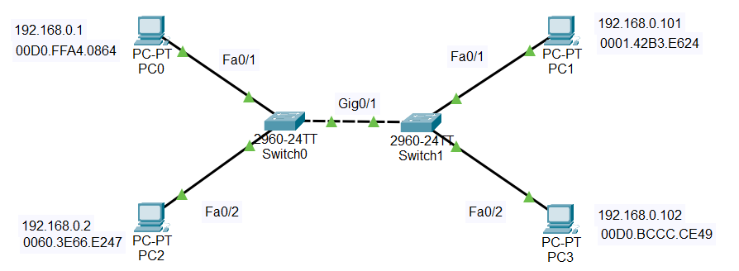

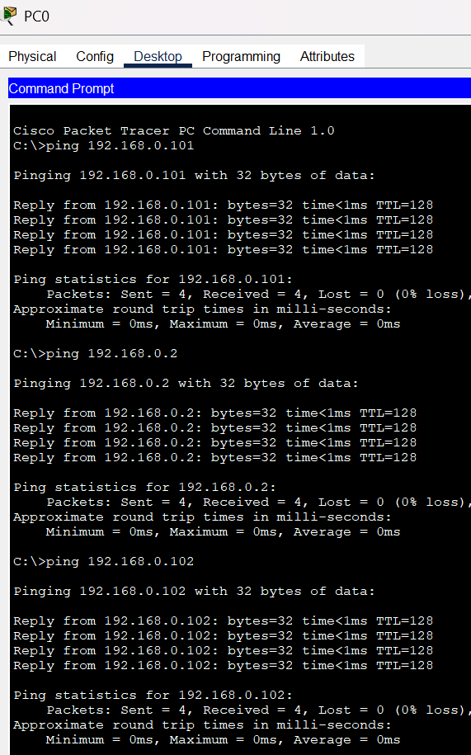

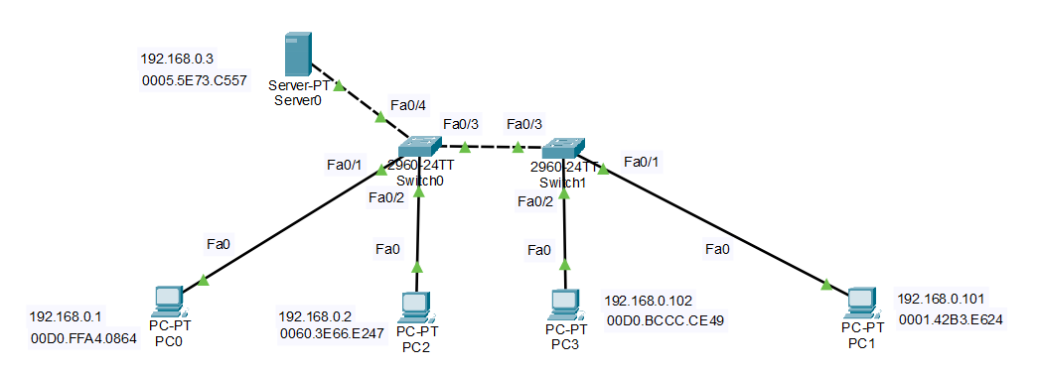**LAB#02 PART(A) – TASK#03**

